

(All rights reserved)

**Interns**: Evans Acheampong and Josiah Lansah

**Course of study**: Computer Engineering and Computer Science

# **Instructor:** Douglas T. Ayitey

# **Date:** October 26th, 2022

**DAILY INTERNSHIP REPORT**

**DAY 7**

**PRATICAL MACHINE LEARNING PROJECTS WITH ARDUINO NANO BLE 33 SENSE**

* **GESTURE RECOGNITION USING ARDUINO NANO 33 BLE SENSE (THIRD PHASE)**
* **ADDED EMOJI BUTTONS (SECOND PHASE)**

After several deliberations and research, we made three different conclusions:

* Check what the emoji button actually entails
* Check the specific issues relating to Linux and Mac OS
* Check if there are any issues relating to the Ameba TensorFlow lite libraries.

The use of the emoji button as an added experience to the gesture recognition project involves:

Sending an emoji character over USB HID when the button is pressed

Note: Only macOS and Linux are supported at this time, and the use of #define is generally discouraged in Arduino examples

The circuit:

- Arduino Nano 33 BLE or Arduino Nano 33 BLE Sense board.

- Button connected to pin 3 and GND.

Using Ubuntu OS on a virtual machine, we manage to make the following accomplishments:

* Successfully downloading and installing Arduino IDE for Linux
* Writing and compiling all the necessary codes in the Arduino IDE
* Testing out Arduino 33 BLE Sense with the Ubuntu Operating System for the emoji button project.

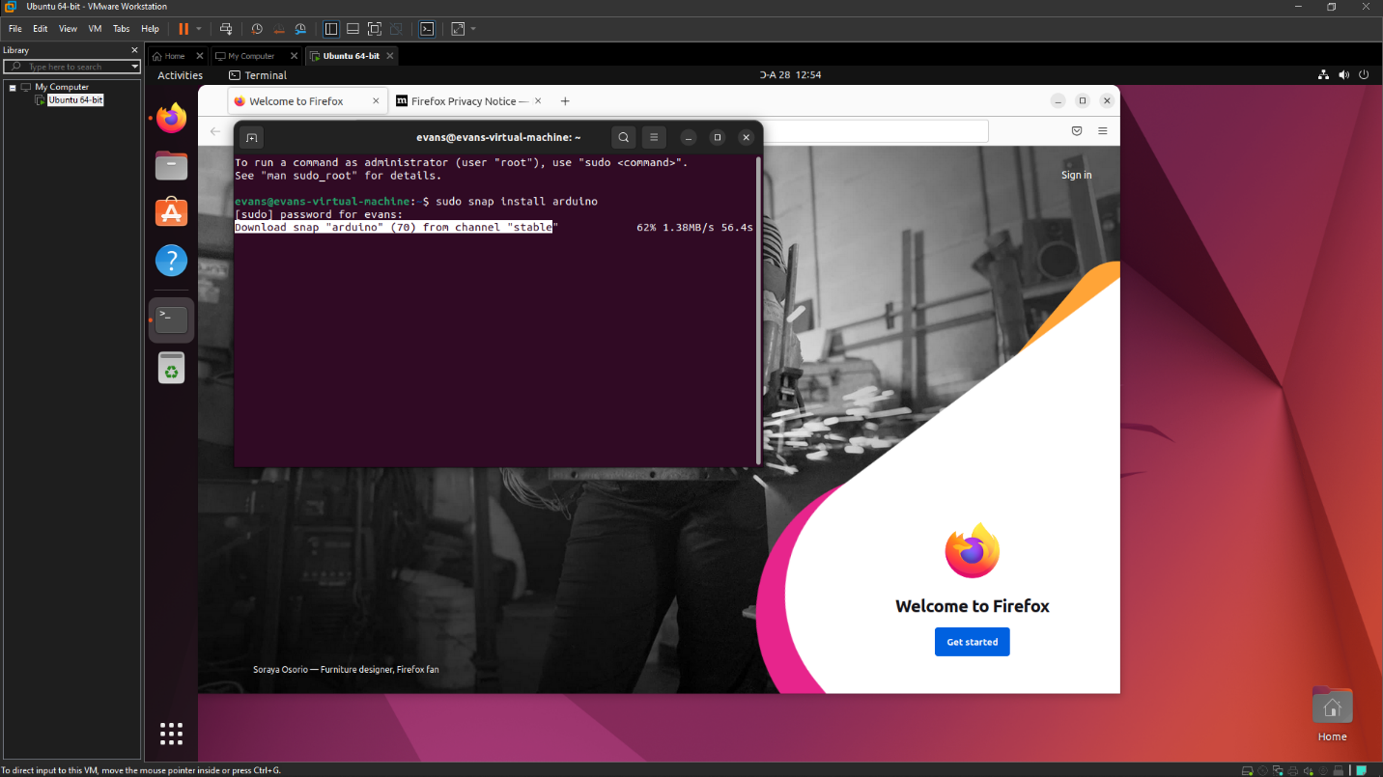

Setting up the Arduino Nano 33 BLE Sense for the added emoji effect

**Hardware and Software Required**

* Arduino Nano 33 BLE Sense
* USB Cable
* Mini motherboard
* Jumper wires
* Arduino IDE
* Button / Switch

Issues pertaining to MAC OS

For MacOS, you also need to enable support for emoji keyboards. Open System Preferences. Choose Keyboard. Select the Input Sources tab. Press the plus button. Search for 'other'. Choose 'Unicode Hex Input'. Press that add button.

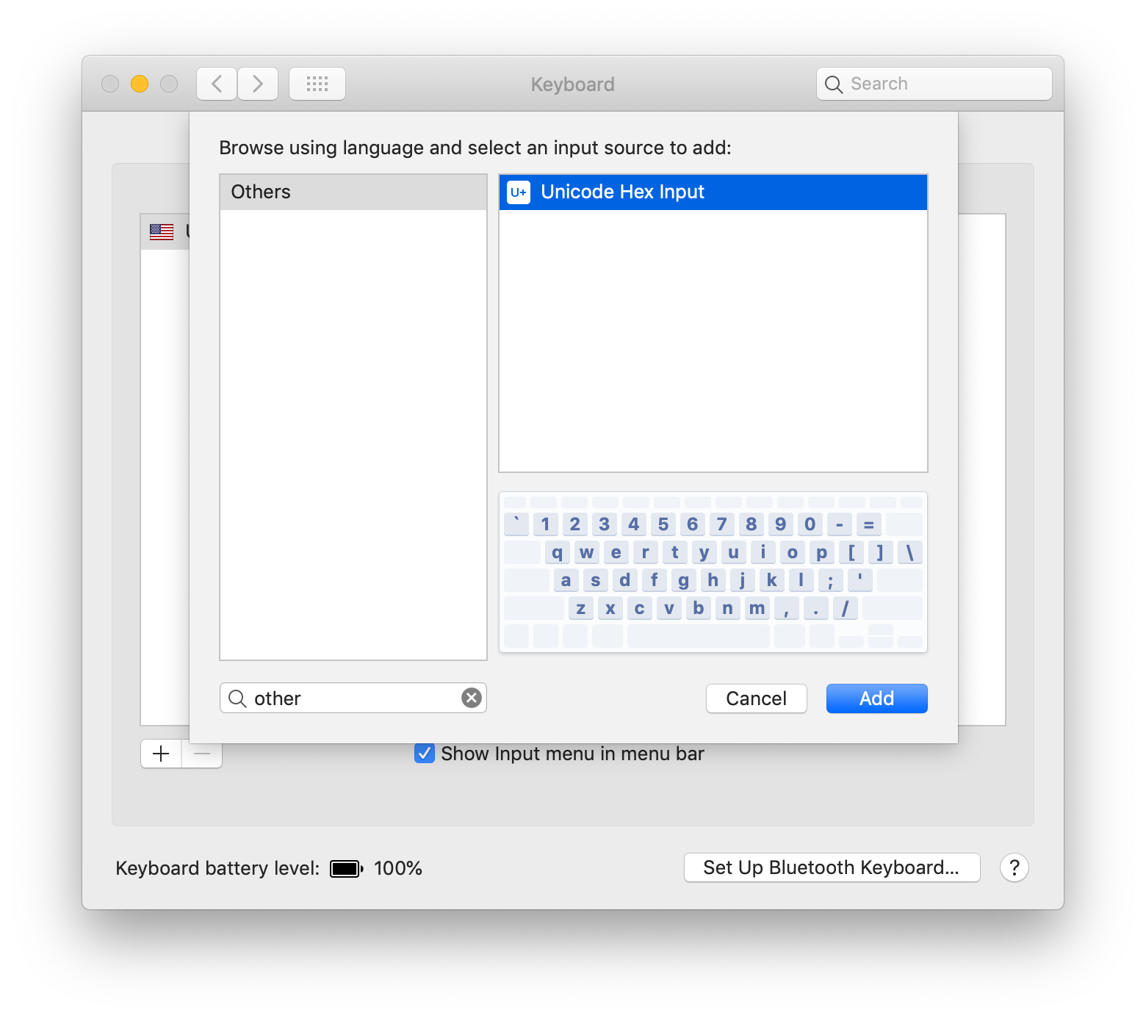

## **Running the Test**

Compile and upload the code onto your Arduino using **Sketch -> Upload**. Open a new [Google Doc](https://doc.new) or another editor that supports emojis. Use your mouse to set focus into the editor. Shake the Arduino to activate the accelerometer and a bicep emoji 💪should appear.

### **Note**

Once you load code that runs the USB Keyboard, the Arduino IDE might not be able to see the serial port when you want to load new code. Double click the reset button on the Nano 33 BLE before you run **Sketch -> Upload**.

**Errors**

After attempting to run the code we were unduly faced with several different errors including void setup and loop errors due to numerous conflictions between the IMU_Classifier and Emoji_Button code and hence another method/OS had to be employed.

**NOTE**

After running several tests and compiling different codes, we concluded that there were no issues whatsoever with the precompiled library (Ameba TensorFlow lite). Hence this meant that the issue(s) faced were solely from the Operating Systems used (MAC and Linux).

**Errors and Project Setbacks for Linux OS**

After hours of debugging, research and generally working with Ubuntu on a virtual machine platform, we came to an abrupt conclusion that using such methods were not feasible for the said project!

**Possible Solutions**

* Using the Windows OS, we managed to “manually” insert various emojis using the in-built emojis in Windows by inserting them at the appropriate places within the code.

The final results are shown below!

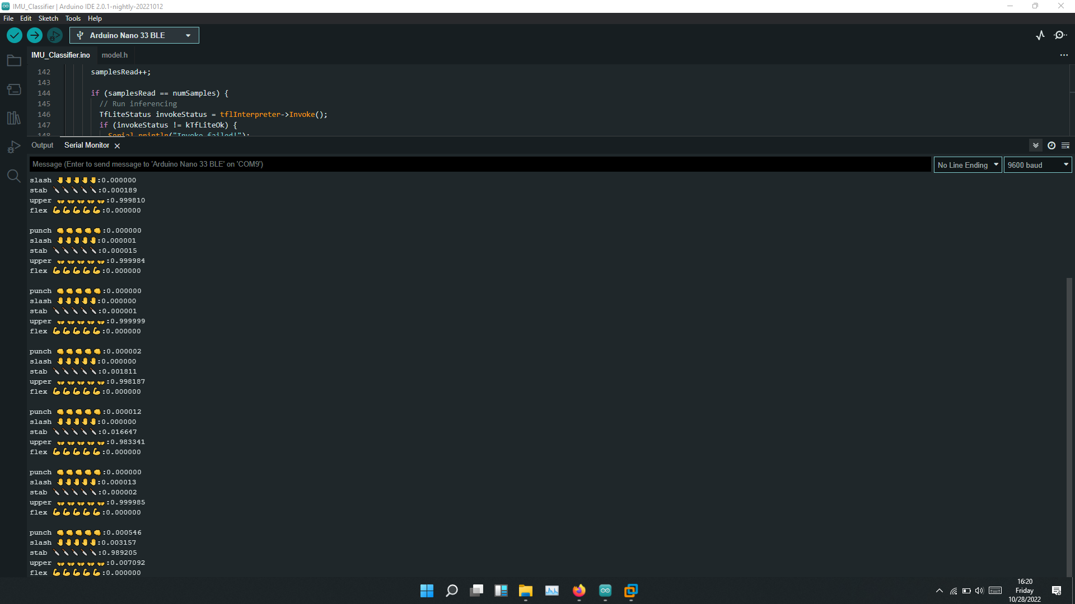

**Conclusion**

* The results above have several different applications including being used as a form of exercise to calculate the number and type of various movements including punch and flex for fitness and training purposes.
* In addition to the added emoji feature, we managed to train and include several other gestures including interesting ones such as stab, slash and upper
* The process is well elaborated in the next report (October 28th- DAY 8(Week 3)

**References**

[1]<https://github.com/arduino/ArduinoTensorFlowLiteTutorials/blob/master/GestureToEmoji/ArduinoSketches/Emoji_Button/Emoji_Button.ino>

[2] <https://blog.arduino.cc/2019/10/15/get-started-with-machine-learning-on-arduino/>

[3] <https://blog.tensorflow.org/2019/11/how-to-get-started-with-machine.html>

[4] <https://github.com/don/tinyml-workshop/blob/master/exercises/exercise9.md>

[5] <https://github.com/don/tinyml-workshop/blob/master/exercises/exercise8.md>